Title: | Door Control Module  SW Architecture static and dynamic

History
Issue status  (Index) | Maturity/Date  (draft/invalid/valid)  (dd-mmm-yyyy) | Author  Department | Check/Release  Department | Description
1.0 | Draft  20-Jan-21 | Rubén Cocoletzi | TBD | Initial Version

Table of Contents
1 Purpose 4
2 Definitions and abbreviations 4
3 Realization constraints and targets 4
4 SW Functional Architecture 5
4.1 Table of functions 5
4.2 Table of functional Interfaces 5
4.3 Functional Interface 5
4.4 Functional Interaction 6
4.4.1 Door Manual Mode 7
4.4.2 Door Remote Mode 8
4.4.3 Auto Lock 9
4.4.4 Window Manual Mode 10
4.4.5 Window Remote Mode 11
5 SW Physical Architecture 12
5.1 Physical Decomposition 12
5.2 Table of SW components 12
5.3 Table of Physical Interfaces 13
5.4 Physical Interfaces 13
5.5 Physical Interaction 14
5.5.1 Door Manual Mode 14
5.5.2 Door Remote Mode 15
5.5.3 Auto Lock 16
5.5.4 Window Manual Mode 17
5.5.5 Window Remote Mode 18
5.6 Describe Dynamic Behavior 19
5.6.1 OS tasks 19
5.6.2 Interrupt Handling 19
5.6.3 Power Modes 20
5.7 Synchronization Mechanisms 20
6 Function to Physical Allocation 20
7 SW Requirements Allocation 20
8 SW Integration Plan 20
9 Functional Safety 21

Purpose
This document has been created to show the functional and physical architecture of door control module. The requirements document was used to define the system’s architecture.

Definitions and abbreviations
Definitions
Actuator | Device that will perform a job

Abbreviations

Rqst | Request
CAN | Controller Area Networ
DCU | Door Control Unit
Btn | Button
Lck | Lock
ADC | Analog Digital Converter
Isr | Interrupt Service Routine
CRC | Cyclic Redundancy Check
References
N° | Document name | Reference
1 | SW Requirements | Commit: 1f9ce2f6b56ac62ace761fed315da0371b8655b3 [1f9ce2f]

Realization constraints and targets

This document shows DCU’s principal characteristics such as DoorControl (Lock and unlock) and WindowControl (Close and open)

SW Functional Architecture

The following tables illustrate principal functions to implement system’s required behavior

Table of functions
Function Name | Description
AntiPinchFunctionality | This function implements the logic to detect if an obstacle is detected during closing window operation.
CanTranslation | This function stores all CAN received signals from the CAN Bus
CalculateCANFrame | This function receives all door and window signals and build the CAN frame to transmit it.
CalculateCrc8Byte | This function calculates the CRC8 byte needed in the CAN frame
CheckConfigurationInfo | This function detects the actual configuration that the board has.
DetermineButtonPressed | This function detects when a button is pressed.
DoorLocking | This function handles all door’s operations.
ErrorManager | This function stops the functionalities that were detected with errors.
UpdateDigitalOutput | This function handles all actuator’s operations

Table of functional Interfaces
Signal/Event | Description
CloseWindowInProgress | Notification that the window is closing
CANCEL_WINDOW_ACTUATION | Signal that is used to request the cancel window
WindowsBtnPressed | Signal that is used to notify that a window button is pressed
LockBtnPressed | Signal that is used to notify that a lock button is pressed
Button_Error | Signal that is used to notify that an error was detected
DoorLock_Error | Signal that is used to notify that an error was detected
Window_Error | Signal that is used to notify that an error was detected
VariantValue | Signal that is used to notify current configuration.
LockingReq | Signal that is used to request a lock to CAN Bus
DoorLockSts | Signal that is used to notify Door lock status  d
ConfortCmd | Signal used by DCU to either lock or unlock the door
VehSpeed | Signal used by DCU to implement autolock functionality
SysPwrMode | Signal used by DCU to implement autolock functionality
LOCK_DOOR_ACTUATION | Signal to request lock door operation
UNLOCK_DOOR_ACTUATION | Signal to request unlock door operation
CLOSE_WINDOW_ACTUATION | Signal to request close window operation
OPEN_WINDOW_ACTUATION | Signal to request open window operation
GlobalCloseWindowActuation | Signal to request global close window operation
GlobalOpenWindowActuation | Signal to request global open window operation

Functional Interface
The following image shows a static interaction among SW functions.

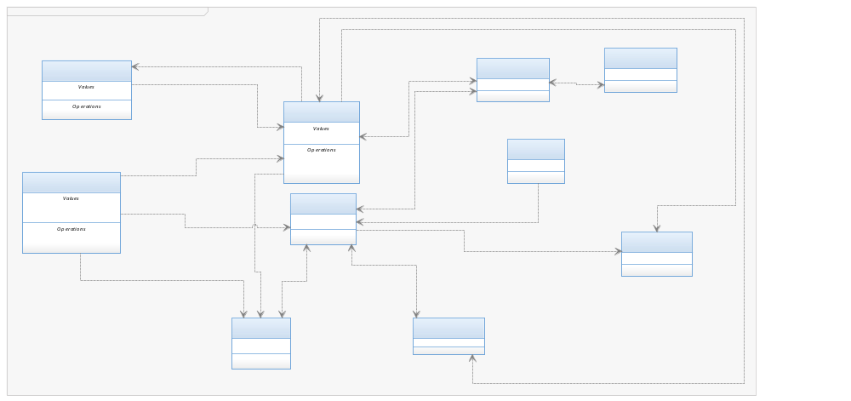

Functional Interaction
The following image shows a dynamic interaction among SW functions.

Door Manual Mode

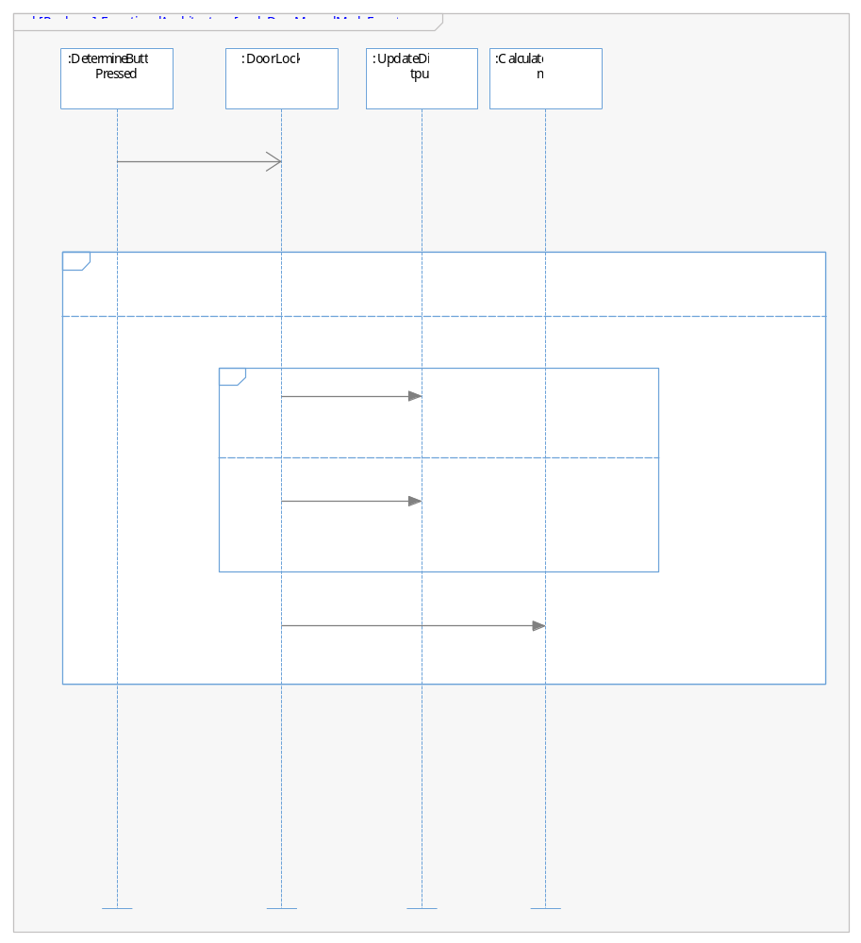

Door Remote Mode
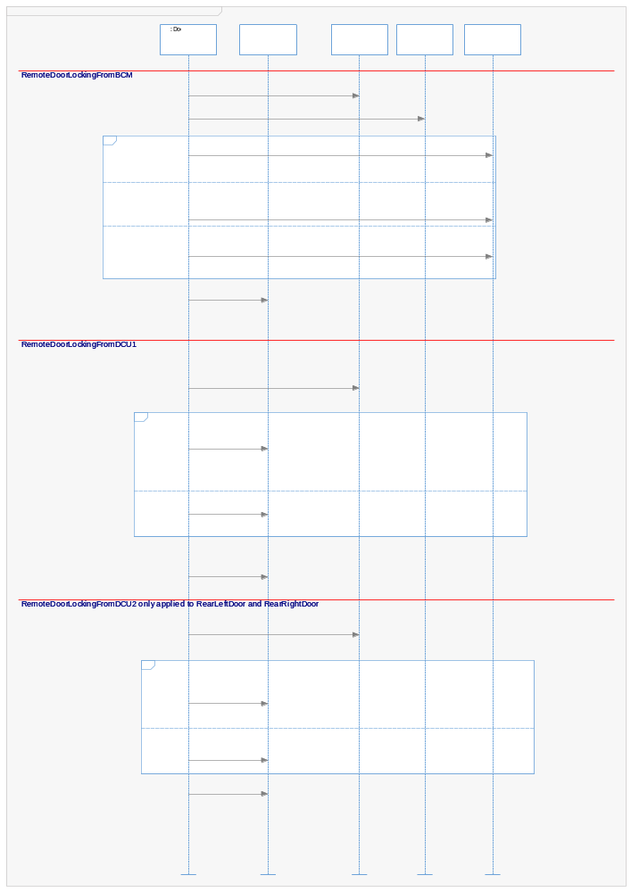

Auto Lock
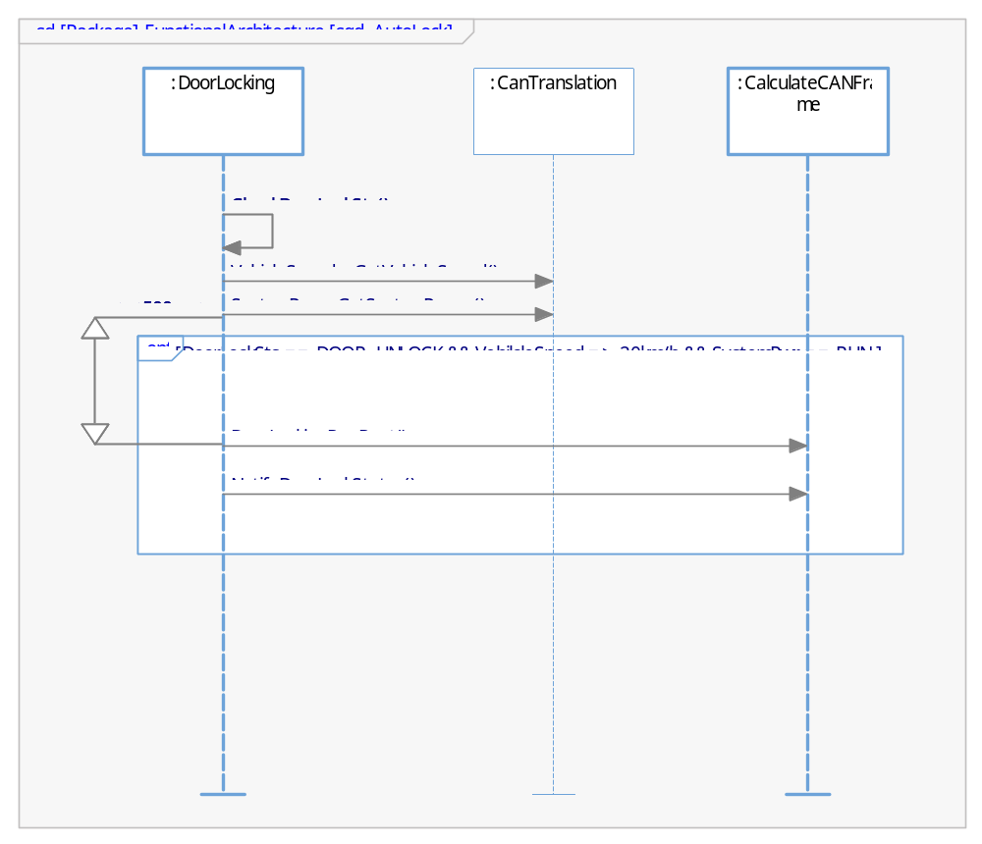

Window Manual Mode
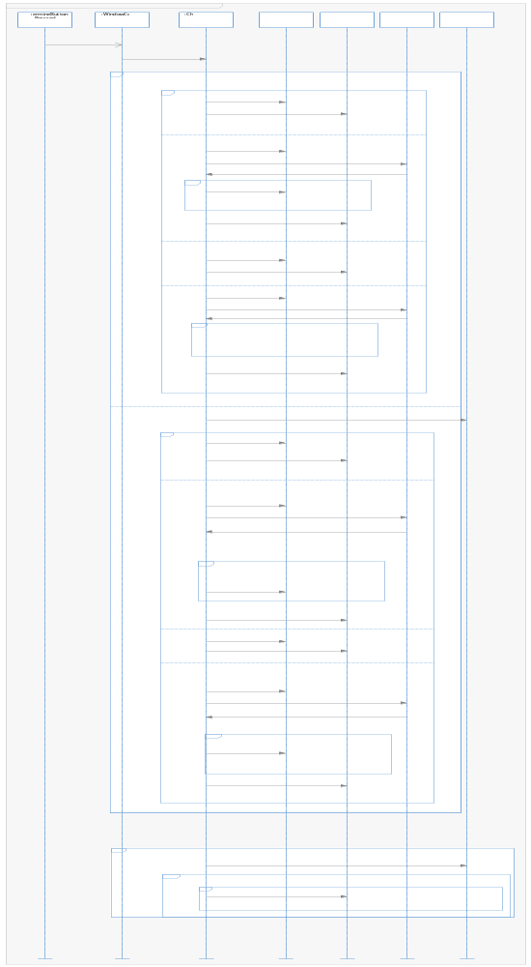

Window Remote Mode
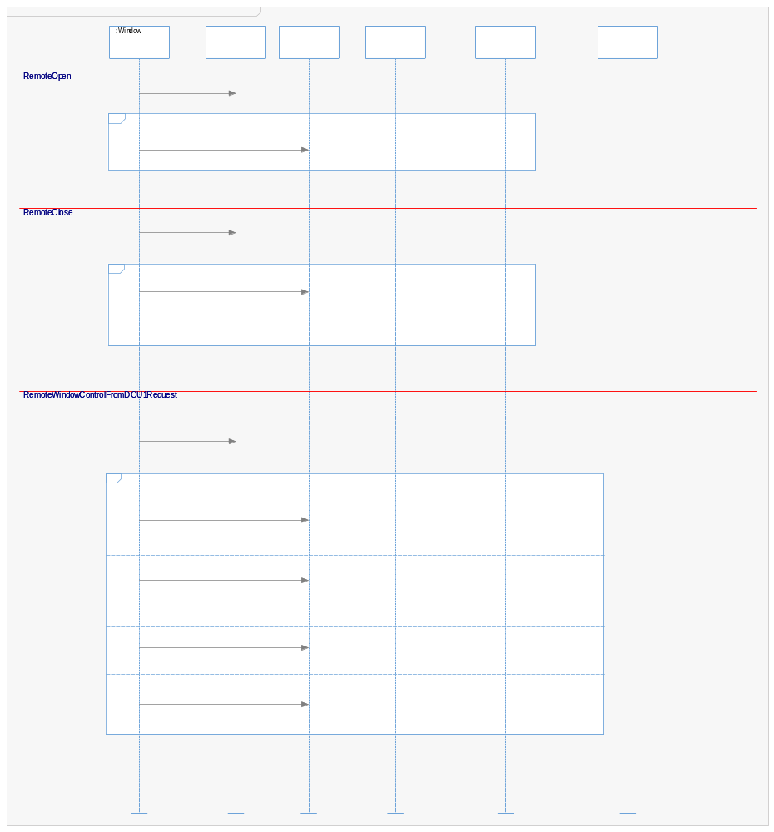

SW Physical Architecture
On the next section are shown all software components identified and them interfaces.

Physical Decomposition
The following block definition diagram shows the software decomposition in SWC.

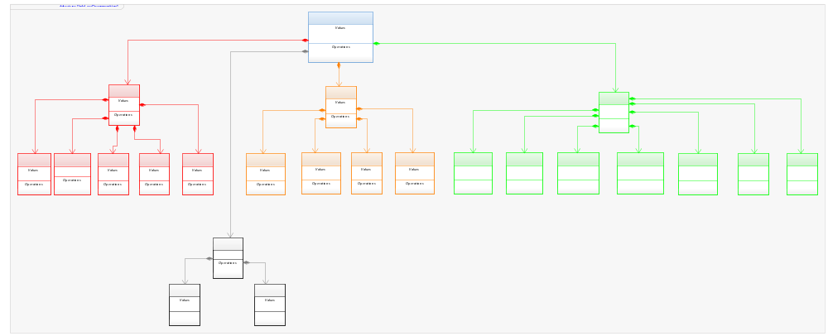

Table of SW components
SWC Name | Description | Estimated Size (KB)
ActuatorManager | Component to handle Door and Window operations | 2
ButtonManager | Component to handle Button’s state | 2
CANDriver | Component to handle driver’s APIs | 5
CANServices | Component to handle CAN validation | 30
ConfigurationInfo | Component to handle configuration in the board | 2
CRC8 | Component to calculate crc8 | 5
DoorLockingApp | Component to handle door locking logic | 30
Errorhandling | Component to manage errors | 2
SafetyManager | Component to detect antipinch events | 2
WindowControlApp | Component to handle window logic | 40

Table of Physical Interfaces
Operation | Description
iAntiPinch | Interface to provide AdcCounts
iSafety | Interface to notify that cancel window operation shall be performed.
iCancelWindow | Interface to notify when window is closing and a possible antipinch event could be triggered.
iConfigurationService | Interface to get current configuration in the board
iWindowButton | Interface to notify when a window button is pressed
iDoorButton | Interface to notify when a door button is pressed
iError | Interface to notify that an error have been triggered
iCanWindowServices | Interface to read/write values from/to CAN bus related to window logic
iActuator | Interface to operate actuators
iCanDoorServices | Interface to read/write values from/to CAN bus related to door logic
iCRC8Services | Interface to calculate crc8 byte
iCAN | Interface to send the calculated CAN frame in application layer

Physical Interfaces
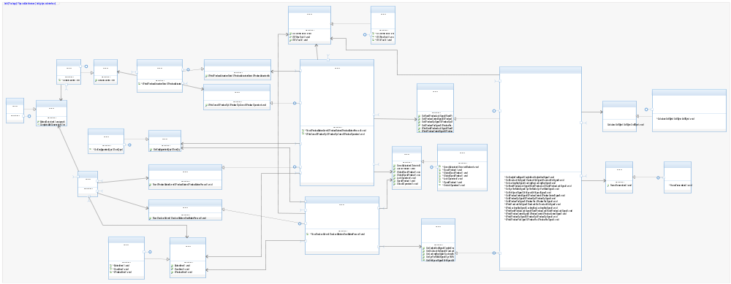

Physical Interaction
The following image shows a dynamic interaction among SW functions.

Door Manual Mode
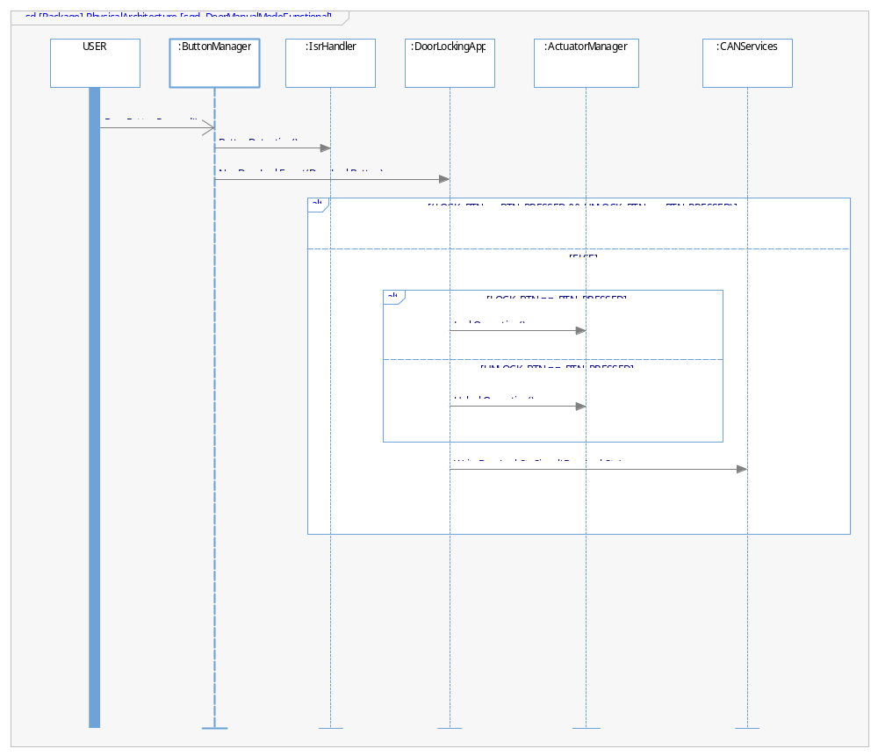

Door Remote Mode
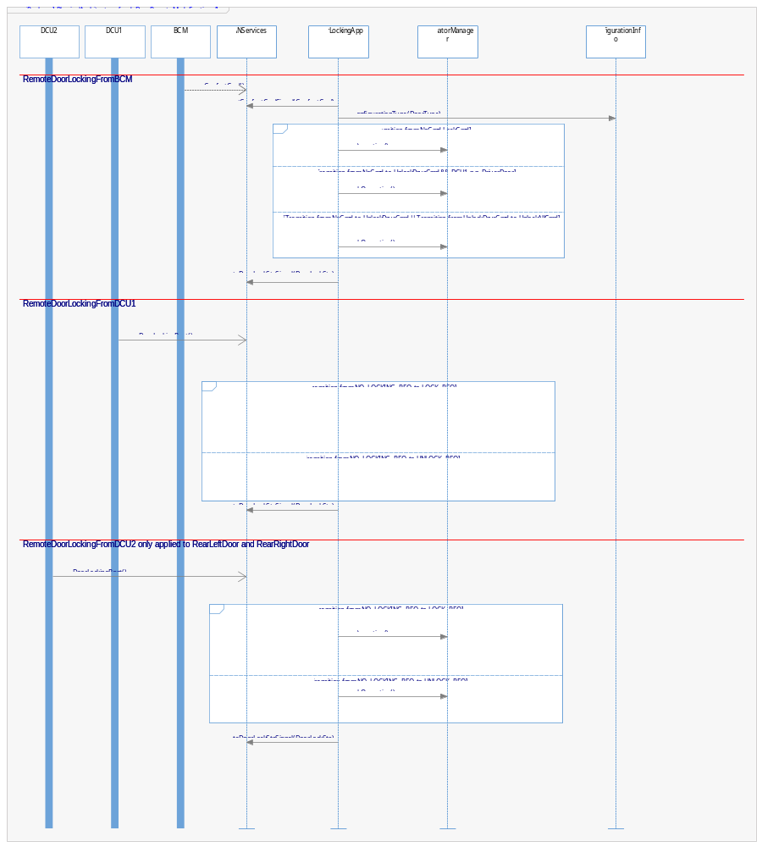

Auto Lock

Window Manual Mode
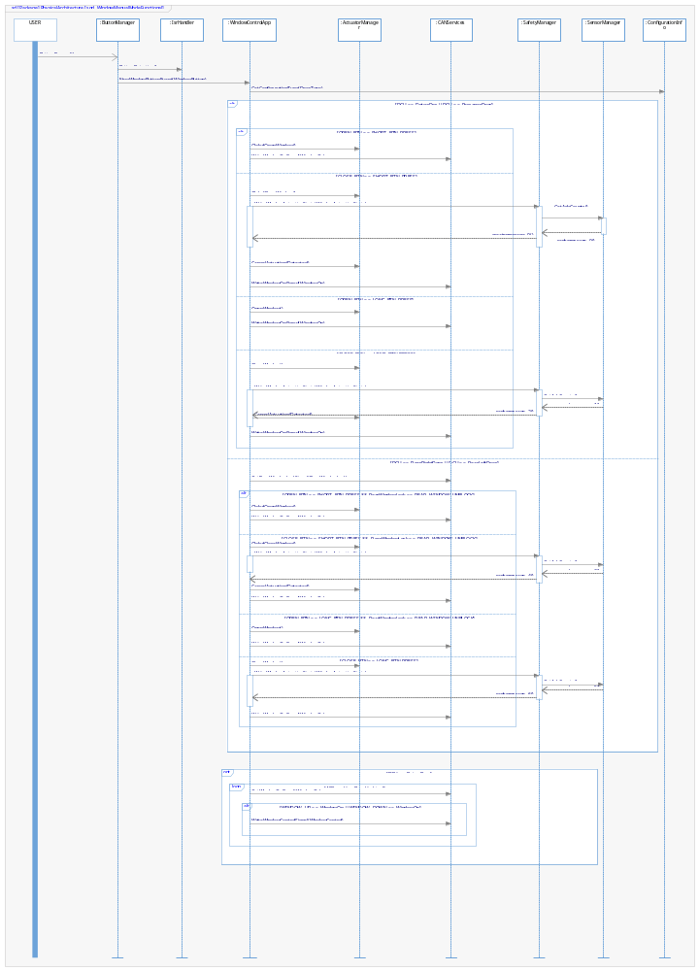

Window Remote Mode
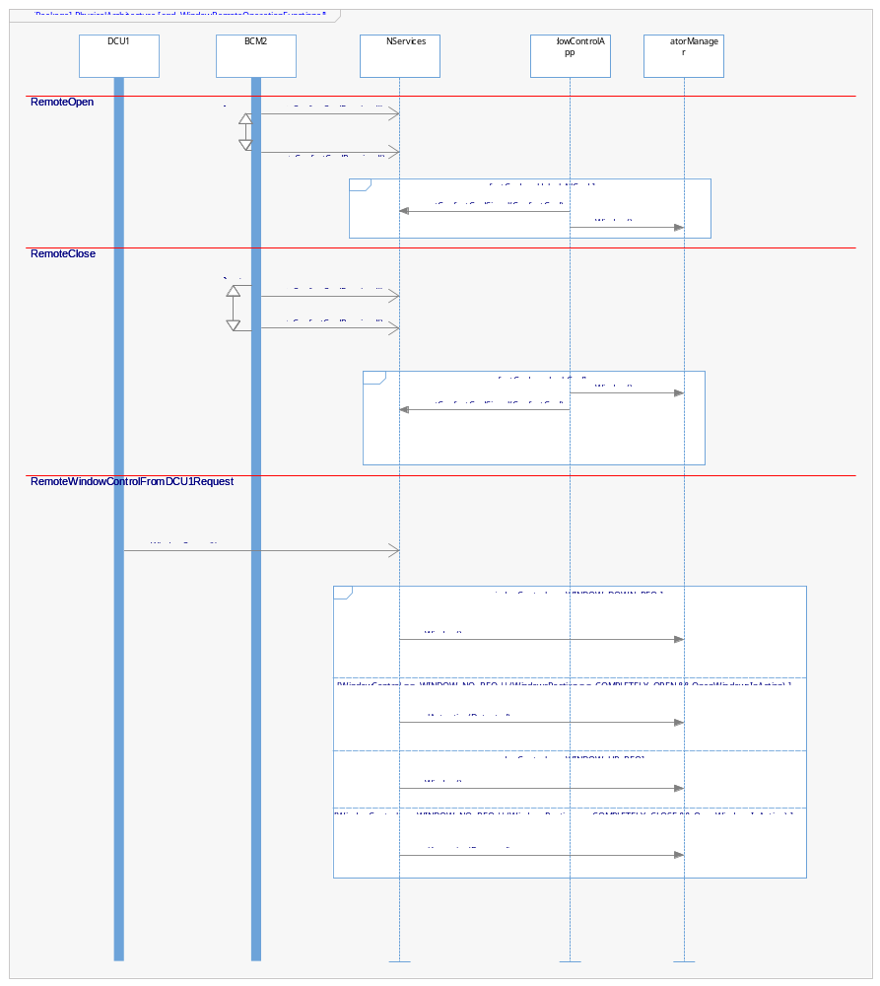

Describe Dynamic Behavior
This chapter shall be used to describe at physical level the runtime behavior of the SW.

OS tasks
OS task | Description | Periodicity (ms) | Period (ms) | Priority | CPU Load (%)
OS_Task10ms | This task execute debounce event on switches and buttons | 10 | 6 |  | 4
OS_Task100ms | This task shall execute CAN transmition and update lock transitions | 100 | 60 |  | 10
OS_Task500ms | This task will perform window transition | 500 | 5 |  | 4
OS_Task1s | This task will perform inhibit operations | 1000 | 1 |  | 4
OS_AntiPinch | Asynchronous task to notify antipinch event | Asynchronous | - |  | 4

Interrupt Handling
ISR task | Description | Priority | CPU Load
Isr_CAN | This interrupt shall execute CAN processing when a message is received |  | 2
Isr_Adc | This interrupt shall update the last adc convertion |  | 2
Isr_GPIO | This interrupt shall notify that a button was pressed |  | 2
Isr_Timer | This interrupt shall notify when a timer has expired |  | 2

Power Modes

Low Power Mode
NA – Door Control Unit does not have low power mode requirements

High Power Mode
All requirements for Door Control Unit are defined to work in high power mode.

Synchronization Mechanisms
TBD

Function to Physical Allocation

Function | SW component | Clarification
AntiPinchFunctionality | SafetyManager
CalculateCANFrame | CANServices
CanTranslation | CANServices
CalculateCrc8Byte | CRC8
UpdateDigitalOutput | ActuatorManager
CheckConfigurationInfo | ConfigurationInfo
DoorLocking | DoorLockingApp
ErrorManager | ErrorHandling
DetermineButtonPressed | ButtonManager
WindowControl | WindowControlApp

SW Requirements Allocation
Software traceability is located in matrix traceability template provided in the requirements folder

SW Integration Plan

Integration Step | Description | SW components | Comments
1 | Integrate Digital inputs provided by NXP. | DigitalInputs | Bottom-Up integration
2 | Integrate Digital outputs provided by NXP | DigitalOutpus | Bottom-Up integration
3 | Integrate Adc firmware provided by NXP | ADC | Bottom-Up integration
4 | Integrate CAN firmware provided by NXP | CAN | Bottom-Up integration
5 | Integrate OS Interrupt services and task handler | OS | Bottom-Up integration
6 | Integrate Actuator manager | ActuatorManager | Bottom-Up integration
7 | Integrate ButtonManager | ButtonManager | Bottom-Up integration
9 | Integrate SensorManger | SensorManager | Bottom-Up integration
8 | Integrate functionalities of CANDriver | CANDriver | Bottom-Up integration
9 | Integrate safety manager swc | SafetyManager | Bottom-Up integration
10 | Integrate CAN Services and CRC8 | CANServices | Integrating can services first due to its more important to have all communication interfaces working properly first. Bottom-Up integration
11 | Integrate ConfigurationInfo | ConfigurationInfo | It’s important identify the configuration of the board due to it is a dependency to the main core functions. Bottom-Up integration
12 | Integrate ErrorHandling module | ErrorHandling | Bottom-Up integration
13 | Integrate DoorLockingApp | DoorLockingApp | I decided to integrate first DoorLockingApp due to it has less requirements to implement. Bottom-Up integration
14 | Integrate WindowControlApp | WindowControlApp | Last component to integrate. Bottom-Up integration

Functional Safety
This chapter will be fill during Module 5

